LAB 4 GRP 7 SESS 201 REPORT

Structural VHDL for Top Level VHDL (Signals, Components, Instances)

ARCHITECTURE SimpleCircuit OF LogicalStep_Lab4_top IS

----------------------------------------------------------------------------------------------------

-- SIGNALS

CONSTANT SIM: boolean := FALSE; -- set to TRUE for simulation runs otherwise keep at 0.

CONSTANT CLK_DIV_SIZE: INTEGER := 26; -- size of vectors for the counters

SIGNAL Main_CLK: STD_LOGIC; -- main clock to drive sequencing of State Machine

SIGNAL bin_counter: UNSIGNED(CLK_DIV_SIZE-1 downto 0); -- := to_unsigned(0,CLK_DIV_SIZE); -- reset binary counter to zero

signal EXT_OUT : std_logic;

signal EXT_EN : std_logic;

signal shift_enable : std_logic;

signal shift_dirout : std_logic;

signal ext_light : std_logic_vector(3 downto 0);

signal Grapple_en : std_logic;

signal seg7_A : std_logic_vector(6 downto 0);

signal seg7_B : std_logic_vector(6 downto 0);

signal Digit1 : std_logic_vector(6 downto 0);

signal Digit2 : std_logic_vector(6 downto 0);

signal Extend : std_logic;

signal Grapple : std_logic;

signal G_led : std_logic;

signal button : std_logic;

signal XTAR : std_logic_vector(3 downto 0);

signal Xcurr : std_logic_vector(3 downto 0) := "0000";

signal Xdrive : std_logic;

signal XOUT : std_logic_vector(3 downto 0);

signal Xup1_down0 : std_logic;

signal Xgrtr : std_logic;

signal Xeq : std_logic;

signal Xless : std_logic;

signal on_countX : std_logic;

signal errorLEDx : std_logic;

signal YTAR : std_logic_vector(3 downto 0);

signal Ycurr : std_logic_vector(3 downto 0) := "0000";

signal YOUT : std_logic_vector(3 downto 0);

signal Ydrive : std_logic;

signal Yup1_down0 : std_logic;

signal Ygrtr : std_logic

signal Yeq : std_logic;

signal Yless : std_logic;

signal on_countY : std_logic;

signal errorLEDy : std_logic;

signal ERR_SIG : std_logic;

------------------------------------------------------------------------------------------------------------------------------------------

------------------------------------------------------------------------------------------------------------------------------------------

-- COMPONENTS USED

--

-- COMPONENT 1 (SevenSegment)

component SevenSegment port (

hex : in std_logic_vector(3 downto 0); -- The 4 bit data to be displayed

sevenseg : out std_logic_vector(6 downto 0) -- 7-bit outputs to a 7-segment

);

end component;

-- COMPONENT 2 (7-Bit Digit Mux)

component segment7_mux port (

clk : in std_logic := '0';

DIN2 : in std_logic_vector(6 downto 0);

DIN1 : in std_logic_vector(6 downto 0);

DOUT : out std_logic_vector(6 downto 0);

DIG2 : out std_logic;

DIG1 : out std_logic

);

end component segment7_mux;

------------------------------------------------------------------------------------------------------------------------------------------

-- COMPONENT 3 (Bidirectional Up Down Shift Counter)

component Bin_Counter4bit port (

Main_CLK : in std_logic := '0';

rst_n : in std_logic := '0';

enable : in std_logic := '0';

up1_down0 : in std_logic := '0';

counter_bits : out std_logic_vector(3 downto 0)

);

End component Bin_Counter4bit;

------------------------------------------------------------------------------------------------------------------------------------------

-- COMPONENT 4 (Extender Moore State Machine)

component Moore_SM port (

clk_input, rst_n, exten, button : IN std_logic;

leds : IN std_logic_vector(3 downto 0);

shift_en, shift_dir, exten_out, grap_en : OUT std_logic

);

End component Moore_SM;

------------------------------------------------------------------------------------------------------------------------------------------

-- COMPONENT 5 (Grappler Moore State Machine)

component Moore_SM2 Port (

clk_input, rst_n, button, enable : IN std_logic;

led : OUT std_logic

);

END component Moore_SM2;

------------------------------------------------------------------------------------------------------------------------------------------

-- COMPONENT 7 (Mealy State Machine)

component Mealy_SM port (

clk_input,XMOTION, YMOTION, EX_OUT,XEQ,XGT,XLT,YEQ,YGT,YLT : IN std_logic;

rst_n : IN std_logic;

clk_enX,clk_enY, Xcount,Ycount,ERRORled,EXTD_EN : OUT std_logic

);

End component Mealy_SM;

-------------------------------------------------------------------------------------------------------------------------------------------- COMPONENT 8 (Bidirectional Left Right Shift Register)

component Bidir_shift_reg PORT(

CLK : in std_logic := '0';

RESET_N : in std_logic := '0';

CLK_EN : in std_logic := '0';

LEFT0_RIGHT1 : in std_logic := '0';

REG_BITS : out std_logic_vector(3 downto 0)

);

end component Bidir_shift_reg;

------------------------------------------------------------------------------------------------------------------------------------------

-- COMPONENT 9 (4-Bit Comparator)

component Compx4 port (

a0 : in std_logic;

a1 : in std_logic;

a2 : in std_logic;

a3 : in std_logic;

b0 : in std_logic;

b1 : in std_logic;

b2 : in std_logic;

b3 : in std_logic;

grtr : out std_logic;

eq : out std_logic;

less : out std_logic

);

end component Compx4;

------------------------------------------------------------------------------------------------------------------------------------------

-- COMPONENT 10 (System Error Digit Flash)

component ErrorFlash port (

clk_input : in std_logic;

rst_n : in std_logic;

INPUT1 : in std_logic_vector(6 downto 0); --when button 3 pressed

INPUT2 : in std_logic_vector(6 downto 0);

Selector : in std_logic;

OUTPUT : out std_logic_vector(6 downto 0)

);

end component ErrorFlash;

------------------------------------------------------------------------------------------------------------------------------------------

------------------------------------------------------------------------------------------------------------------------------------------

BEGIN

-- CLOCKING GENERATOR WHICH DIVIDES THE INPUT CLOCK DOWN TO A LOWER FREQUENCY

BinCLK: PROCESS(clkin_50, rst_n) is

BEGIN

IF (rising_edge(clkin_50)) THEN -- binary counter increments on rising clock edge

bin_counter <= bin_counter + 1;

END IF;

END PROCESS;

Clock_Source:

Main_Clk <=

clkin_50 when sim = TRUE else -- for simulations only

std_logic(bin_counter(23)); -- for real FPGA operation

-- - - - - - - - - - - - - - - - - - - - - - - - - - - - - - - - - - - - - - - - - - - - - - - - - - - - - - - - - - - - - - - - - - - - - - - - - - - - - - - - - - - -

-- IMPLEMENTATION AND INSTANCES --

XDRIVE <= pb(3);

YDRIVE <= pb(2);

button <= pb(0);

-- Mealy State Machine --

MEALY0: Mealy_SM port map

(Main_CLK,XDRIVE,YDRIVE,EXT_OUT,Xeq,Xgrtr,Xless,Yeq,Ygrtr,Yless,rst_n,on_countX,on_countY,Xup1_down0,Yup1_down0,ERR_SIG,EXT_EN);

-- UP/DOWN counting and Comparing of X-Coordinate -- For Motion of X

INST1: Bin_Counter4bit port map (Main_CLK,rst_n,on_countX,Xup1_down0,Xcurr);

INST2: Compx4 port map (Xcurr(0),Xcurr(1),Xcurr(2),Xcurr(3),sw(4),sw(5),sw(6),sw(7),Xgrtr,Xeq,Xless); --compares target X coordinate with current;

-- UP/DOWN counting and Comparing of Y-Coordinate -- For Motion of Y

INST3: Bin_Counter4bit port map (Main_CLK,rst_n,on_countY,Yup1_down0,Ycurr);

INST4: Compx4 port map (Ycurr(0),Ycurr(1),Ycurr(2),Ycurr(3),sw(0),sw(1),sw(2),sw(3),Ygrtr,Yeq,Yless); --compares target X coordinate with current;

-- Extender Moore State Machine & Motion of Extender with Bit Shifter--

INST5: Moore_SM port map(Main_CLK,rst_n,EXT_EN,pb(1),ext_light,shift_enable,shift_dirout,EXT_OUT,Grapple_en);

INST6: Bidir_shift_reg port map(Main_CLK,rst_n,shift_enable,shift_dirout,ext_light);

-- Grappler Moore State Machine --

INST7: Moore_SM2 port map (Main_CLK, rst_n, button, Grapple_en, G_led);

-- Extender Arm Output Lights --

leds(7) <= ext_light(3);

leds(6) <= ext_light(2);

leds(5) <= ext_light(1);

leds(4) <= ext_light(0);

-- Grappler Output Light --

leds(3) <= G_led;

-- Switch Inputs for Target --

YTAR <= sw(3 downto 0);

XTAR <= sw(7 downto 4);

with XDRIVE select

XOUT <= Xcurr when '0',

XTAR when '1';

with YDRIVE select

YOUT <= Ycurr when '0',

YTAR when '1';

-- 7 Segment Display Decoder --

INST20: SevenSegment port map(XOUT, seg7_A);

INST30: SevenSegment port map(YOUT, seg7_B);

-- SYSTEM ERROR Digit Display Flash Sate Machine --

INST35: ErrorFlash port map (Main_CLK, rst_n, "0000000", seg7_A, ERR_SIG, Digit1);

INST36: ErrorFlash port map (Main_CLK, rst_n, "0000000", seg7_B, ERR_SIG, Digit2);

leds(0) <= ERR_SIG;

-- Display the Current Or Target Digits on the 7-Bit Display --

INST40: segment7_mux port map(clkin_50, Digit1, Digit2, seg7_data, seg7_char1, seg7_char2);

---------------------------------------------------------------------------------------------------

END SimpleCircuit;

SIMULATIONS

Simulation of 8bit Shift Register -

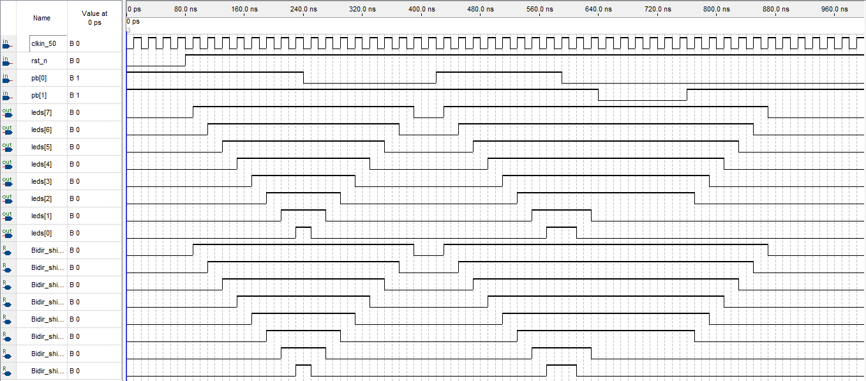

and 8 bit Binary counter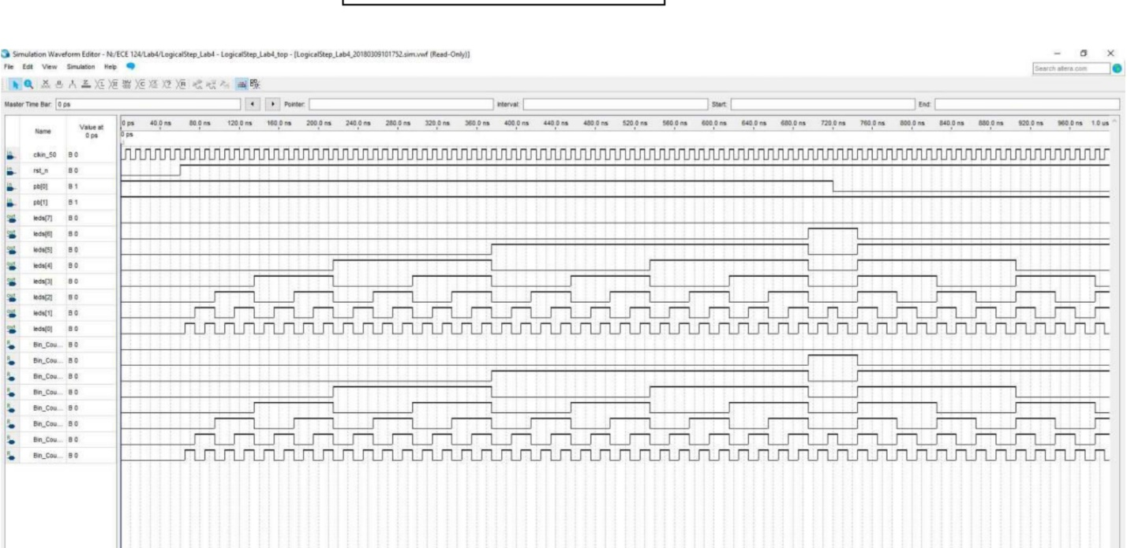

------------------------------------------------------------------------------------------------------------------------------------------

STATE MACHINE DIAGRAMS

Moore State Machine 2 (Grappler)

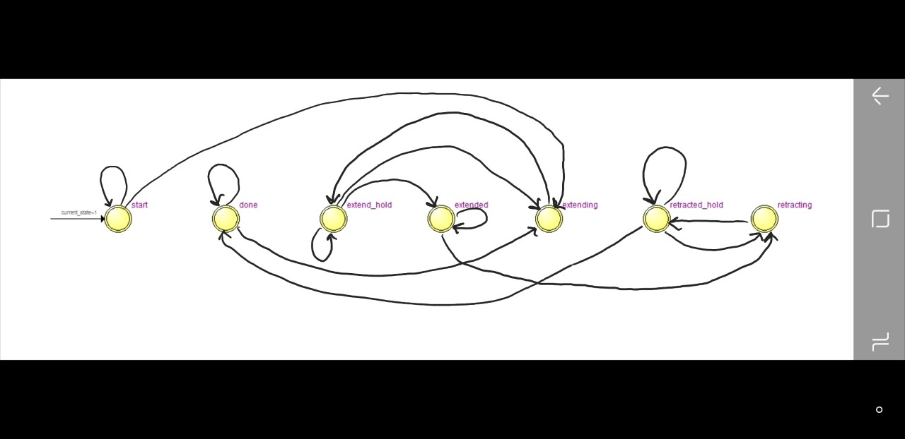

Moore State Machine (Extender)

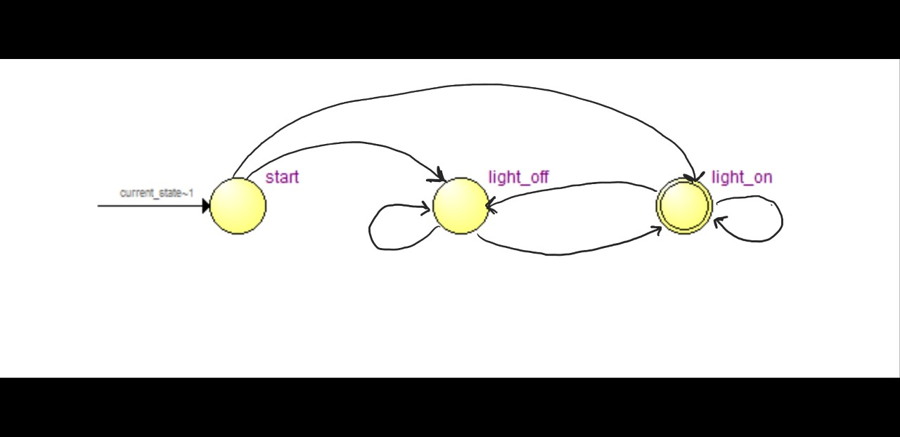

Mealy State Machine

(Y Motion)

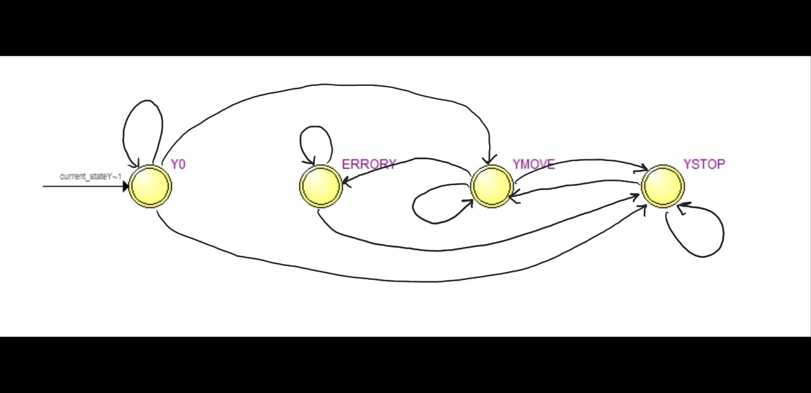

Mealy State Machine

(X Motion)

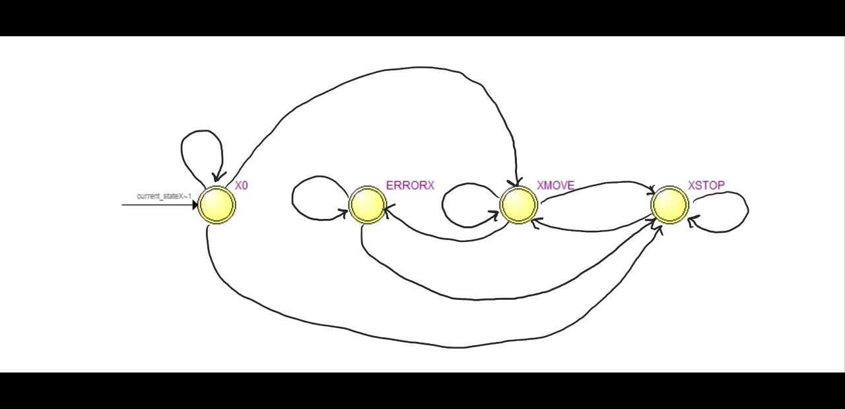

------------------------------------------------------------------------------------------------------------------------------------------

Moore State Machine (VHDL Code) (Extender)

-- We Programmed our extender such that it continues to extend as we hold down the push button

library ieee;

use ieee.std_logic_1164.all;

use ieee.numeric_std.all;

Entity Moore_SM IS Port

(

clk_input, rst_n, exten, button : IN std_logic;

leds : IN std_logic_vector(3 downto 0);

shift_en, shift_dir, exten_out, grap_en : OUT std_logic

);

END ENTITY;

Architecture SM of Moore_SM is

TYPE STATE_NAMES IS (start,extending,extend_hold, extended, retracting, retracted_hold, done); -- list all the STATE_NAMES values

SIGNAL current_state, next_state : STATE_NAMES; -- signals of type STATE_NAMES

BEGIN

--------------------------------------------------------------------------------

--State Machine:

--------------------------------------------------------------------------------

-- REGISTER_LOGIC PROCESS:

Register_Section: PROCESS (clk_input, rst_n, next_state) -- this process synchronizes the activity to a clock

BEGIN

IF (rst_n = '0') THEN

current_state <= start;

ELSIF(rising_edge(clk_input)) THEN

current_state <= next_State;

END IF;

END PROCESS;

-- TRANSITION LOGIC PROCESS

Transition_Section: PROCESS (exten, button, leds, current_state)

BEGIN

CASE current_state IS

WHEN start =>

IF(exten ='1' AND button='0') THEN

next_state <= extending;

ELSE

next_state <= start;

END IF;

WHEN extending =>

IF(button='1') THEN

next_state <= extend_hold;

END IF;

WHEN extend_hold =>

IF(leds="1111") THEN

next_state <= extended;

ELSIF(button='0') THEN

next_state <= extending;

ELSE

next_state <= extend_hold;

END IF;

WHEN extended =>

IF(button='0') THEN

next_state <= retracting;

ELSE

next_state <= extended;

END IF;

WHEN retracting =>

IF(button='1')THEN

next_state <= retracted_hold;

END IF;

WHEN retracted_hold =>

IF(leds="0000") THEN

next_state <= done;

ELSIF(button='0') THEN

next_state <= retracting;

ELSE

next_state <= retracted_hold;

END IF;

WHEN done =>

IF(button='0' AND exten ='1') THEN

next_state <= extending;

ELSE

next_state <= done;

END IF;

END CASE;

END PROCESS;

-- DECODER SECTION PROCESS

Decoder_Section: PROCESS (current_state)

BEGIN

CASE current_state IS

WHEN start =>

shift_en <= '0';

shift_dir <= '0';

exten_out <= '0';

grap_en <= '0';

WHEN extending =>

shift_en <= '1';

shift_dir <= '1';

exten_out <= '1';

grap_en <= '0';

WHEN retracting =>

shift_en <= '1';

shift_dir <= '0';

exten_out <= '1';

grap_en <= '0';

WHEN extended =>

shift_en <= '0';

shift_dir <= '0';

exten_out <= '1';

grap_en <= '1';

WHEN done =>

shift_en <= '0';

shift_dir <= '0';

exten_out <= '0';

grap_en <= '0';

WHEN others =>

shift_en <= '0';

shift_dir <= '0';

exten_out <= '1';

grap_en <= '0';

END CASE;

END PROCESS;

END ARCHITECTURE SM;

Moore State Machine 2 (VHDL Code) (Grappler Code)

library ieee;

use ieee.std_logic_1164.all;

use ieee.numeric_std.all;

Entity Moore_SM2 IS Port

(

clk_input, rst_n, button, enable : IN std_logic;

led : OUT std_logic

);

END ENTITY;

Architecture SM2 of Moore_SM2 is

TYPE STATE_NAMES IS (start, light_on, light_off); -- list all the STATE_NAMES values

SIGNAL current_state, next_state : STATE_NAMES; -- signals of type STATE_NAMES

BEGIN

--------------------------------------------------------------------------------

--State Machine:

--------------------------------------------------------------------------------

-- REGISTER_LOGIC PROCESS:

Register_Section: PROCESS (clk_input, rst_n, next_state) -- this process synchronizes the activity to a clock

BEGIN

IF (rst_n = '0') THEN

current_state <= start;

ELSIF(rising_edge(clk_input)) THEN

current_state <= next_State;

END IF;

END PROCESS;

-- TRANSITION LOGIC PROCESS

Transition_Section: PROCESS (button, enable, current_state)

BEGIN

CASE current_state IS

WHEN start =>

IF (enable = '1' AND button = '0') then

next_state <= light_on;

ELSIF (enable ='0' OR button = '1') then

next_state <= light_off;

END IF;

WHEN light_on =>

IF (enable = '1' AND button = '0') then

next_state <= light_on;

ELSIF (enable ='0' OR button = '1') then

next_state <= light_off;

END IF;

WHEN light_off =>

IF (enable = '1' AND button = '0') then

next_state <= light_on;

ELSIF (enable ='0' OR button = '1') then

next_state <= light_off;

END IF;

END CASE;

END PROCESS;

-- DECODER SECTION PROCESS

Decoder_Section: PROCESS (current_state)

BEGIN

CASE current_state IS

WHEN start =>

led <= '0';

WHEN light_on =>

If (enable = '1' AND button = '0') then

led <= '1';

End if;

WHEN light_off =>

led <= '0';

END CASE;

END PROCESS;

END ARCHITECTURE SM2;

Mealy State Machine (VHDL Code) (XY Motion)

library ieee;

use ieee.std_logic_1164.all;

use ieee.numeric_std.all;

Entity Mealy_SM IS Port

(

clk_input,XMOTION, YMOTION, EX_OUT,XEQ,XGT,XLT,YEQ,YGT,YLT : IN std_logic;

rst_n : in std_logic := '0';

clk_enX,clk_enY, Xcount,Ycount,ERRORled,EXTD_EN : OUT std_logic

);

END ENTITY;

Architecture SM of Mealy_SM is

TYPE STATE_NAMESX IS (X0,XMOVE,XSTOP,ERRORX); -- list all the STATE_NAMES values

TYPE STATE_NAMESY IS (Y0,YMOVE,YSTOP,ERRORY);

SIGNAL current_stateX, next_stateX : STATE_NAMESX; -- signals of type STATE_NAMES

SIGNAL current_stateY, next_stateY : STATE_NAMESY; -- signals of type STATE_NAMES

SIGNAL EXTDX : std_logic;

SIGNAL EXTDY : std_logic;

SIGNAL ledX : std_logic := '0';

SIGNAL ledY : std_logic := '0';

signal EXTD_OUT :std_logic;

BEGIN

EXTD_OUT <= EX_OUT;

--------------------------------------------------------------------------------

--State Machine:

--------------------------------------------------------------------------------

-- REGISTER_LOGIC PROCESS:

Register_Section: PROCESS (clk_input, rst_n, next_stateX,next_stateY) -- this process synchronizes the activity to a clock

BEGIN

IF (rst_n = '0') THEN

current_stateX <= X0;

current_stateY <= Y0;

ELSIF(rising_edge(clk_input)) THEN

current_stateX <= next_StateX;

current_stateY <= next_StateY;

END IF;

END PROCESS;

-- TRANSITION LOGIC PROCESS

Transition_Section: PROCESS (XMOTION, EXTD_OUT, XEQ, XGT,XLT, current_stateX)

BEGIN

CASE current_stateX IS

WHEN X0 =>

IF(XMOTION = '0' AND XEQ = '0' AND EXTD_OUT = '0') THEN

next_stateX <= XMOVE;

ELSIF (XEQ = '1') THEN

next_stateX <= XSTOP;

ELSE

next_stateX <= X0;

END IF;

WHEN XMOVE =>

IF(EXTD_OUT = '1') THEN

next_stateX <= ERRORX;

ELSIF (XMOTION='0' AND XLT = '1') THEN

next_stateX <= XMOVE;

ELSIF(XMOTION='0' AND XGT = '1') THEN

next_stateX <= XMOVE;

ELSIF(XMOTION='1' OR XEQ = '1') THEN

next_stateX <= XSTOP;

END IF;

WHEN XSTOP =>

IF(XMOTION='0') THEN

next_stateX <= XMOVE;

ELSE

next_stateX <= XSTOP;

END IF;

WHEN ERRORX =>

IF(EXTD_OUT = '0') THEN

next_stateX <= XSTOP;

ELSE

next_stateX <= ERRORX;

END IF;

END CASE;

END PROCESS;

-- DECODER SECTION PROCESS

Decoder_Section: PROCESS (XMOTION, EXTD_OUT, XEQ, XGT,XLT, current_stateX)

BEGIN

CASE current_stateX IS

WHEN X0 =>

EXTDX <= '0';

WHEN XMOVE =>

EXTDX <= '0';

clk_enX <= '1';

IF(XMOTION='0' AND XGT = '1') THEN

Xcount <= '0';

ELSIF(XMOTION='1' OR XEQ = '1') THEN

clk_enX <= '0';

ELSIF (XMOTION='0' AND XLT = '1') THEN

Xcount <= '1';

END IF;

WHEN XSTOP =>

IF (XEQ = '1') THEN

EXTDX <= '1';

ELSE

EXTDX <= '0';

END IF;

WHEN ERRORX =>

ledX <= '1';

IF(EXTD_OUT = '0') THEN

ledX <= '0';

END IF;

END CASE;

END PROCESS;

Transition_Section2: PROCESS (YMOTION, EXTD_OUT,YEQ, YGT,YLT, current_stateY)

BEGIN

CASE current_stateY IS

WHEN Y0 =>

IF(YMOTION = '0' AND YEQ = '0' AND EXTD_OUT = '0') THEN

next_stateY <= YMOVE;

ELSIF (YEQ = '1') THEN

next_stateY <= YSTOP;

ELSIF (EXTD_OUT = '1') THEN

next_stateY <= ERRORY;

ELSE

next_stateY <= Y0;

END IF;

WHEN YMOVE =>

IF (EXTD_OUT = '1') THEN

next_stateY <= ERRORY;

ELSIF(YMOTION='0' AND YLT = '1') THEN

next_stateY <= YMOVE;

ELSIF(YMOTION='0' AND YGT = '1') THEN

next_stateY <= YMOVE;

ELSIF(YMOTION='1' OR YEQ = '1') THEN

next_stateY <= YSTOP;

END IF;

WHEN YSTOP =>

IF(YMOTION='0') THEN

next_stateY <= YMOVE;

ELSE

next_stateY <= YSTOP;

END IF;

WHEN ERRORY =>

IF(EXTD_OUT = '0') THEN

next_stateY <= YSTOP;

ELSE

next_stateY <= ERRORY;

END IF;

END CASE;

END PROCESS;

-- DECODER SECTION PROCESS

Decoder_Section2: PROCESS (YMOTION, EXTD_OUT,YEQ, YGT,YLT, current_stateY)

BEGIN

CASE current_stateY IS

WHEN Y0 =>

EXTDY <= '0';

WHEN YMOVE =>

EXTDY <= '0';

clk_enY <= '1';

IF(YMOTION='0' AND YGT = '1') THEN

Ycount <= '0';

ELSIF(YMOTION='1' OR YEQ = '1') THEN

clk_enY <= '0';

ELSIF (YMOTION='0' AND YLT = '1') THEN

Ycount <= '1';

END IF;

WHEN YSTOP =>

IF (YEQ = '1') THEN

EXTDY <= '1';

ELSE

EXTDY <= '0';

END IF;

WHEN ERRORY =>

ledY <= '1';

IF(EXTD_OUT = '0') THEN

ledY <= '0';

END IF;

END CASE;

END PROCESS;

ERRORled <= ledX OR ledY;

EXTD_EN <= EXTDX AND EXTDY;

END ARCHITECTURE SM;

Moore vs Mealy State Machine

Mealy State Machine is a finite-state machine whose output values are determined both by its current state and the current inputs.

Moore State Machine is a state machine whose output values are determined only by its current state.

In our VHDL code implementation we have used the similar logic to build the Moore and Mealy State Machines.

Fitter Report

